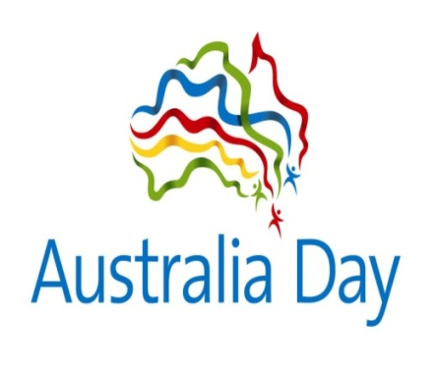
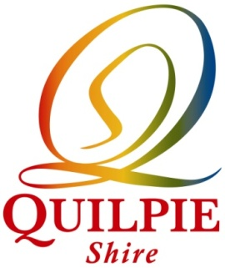

Australia Day Awards 2021

COMMUNITY GROUP AWARD Quilpie Sporting Clays Club Inc.

SPORTS & RECREATION AWARD Quilpie Motorcyclist Association Ltd

OUTSTANDING JUNIOR ACHIEVEMENT AWARD Chelsea McConnell

